|  |
| --- |
|  |
| Capstone Event Document |

**WINGS**

Report #1 – Event Introduction

|  |  |  |
| --- | --- | --- |
| **WingS** | | |
| **Group Members** | Đào Trọng Nghĩa | SE03220 |
| Lê Hồng Nhiên | SE03377 |
| Tạ Ngọc Duy | SE03267 |
| Đỗ Văn Tuấn | SE03297 |
| Hoàng Anh Tuấn | SE03108 |
| **Supervisor** | Mr. Nguyễn Văn Sang | |
| **Event code** | WS | |

**- Hanoi, 09/2016 –**

# SIGNATURE PAGE

AUTHOR: Tạ Ngọc Duy 06/09/2016

Team member

REVIEWERS: Đào Trọng Nghĩa 07/09/2016

Event manager

APPROVAL: Nguyễn Văn Sang --/--/2016

Supervisor

Record of change

*A - Added M - Modified D – Deleted

|  |  |  |  |  |  |
| --- | --- | --- | --- | --- | --- |
| Effective Date | Changed Item | A,M,D | Change Description | Reason for Change | Rev. Number |
| 06/Sep/2016 | Create Introduction | A | Create Introduction | First version | 1.0 |
|  |  |  |  |  |  |
|  |  |  |  |  |  |
|  |  |  |  |  |  |
|  |  |  |  |  |  |
|  |  |  |  |  |  |
|  |  |  |  |  |  |
|  |  |  |  |  |  |
|  |  |  |  |  |  |
|  |  |  |  |  |  |
|  |  |  |  |  |  |
|  |  |  |  |  |  |
|  |  |  |  |  |  |
|  |  |  |  |  |  |
|  |  |  |  |  |  |
|  |  |  |  |  |  |
|  |  |  |  |  |  |
|  |  |  |  |  |  |
|  |  |  |  |  |  |
|  |  |  |  |  |  |
|  |  |  |  |  |  |
|  |  |  |  |  |  |
|  |  |  |  |  |  |
|  |  |  |  |  |  |

Table Contents

SIGNATURE PAGE 1

1 INTRODUCTION 3

1.1 Purpose 3

1.2 Acronyms and Definitions 3

2 ABSTRACT 3

3 LITERATURE REVIEW 3

4 PROPOSAL 6

4.1 The idea 6

4.2 Objectives 6

4.3 Brief description about system 6

4.4 System features 7

4.4.1 Client features 7

4.4.2 Admin features 8

5 BENEFIT FROM EVENT 9

5.1 For our group 9

5.2 For Community 9

6 CRITICAL ASSUMPTION AND CONSTRAINTS 9

7 POTENTIAL RISKS 9

8 REFERENCES 10

# INTRODUCTION

## Purpose

This document is created as the introduction for event WingS – our Capstone Event at FPT University. In this document, we will descript the overview of some existing systems, the initial idea for our event, a brief description about our expected system and some potential risks, critical assumptions, constrains. Moreover, this document also shows opportunities what it offers for users.

## Acronyms and Definitions

|  |  |
| --- | --- |
| **Acronym & Abbreviation** | **Definition** |
| WS | WingS |
| FU | FPT University |
| Q&A | Question and Answer |

**Table 1-1:** Definitions and Acronyms

# ABSTRACT

WS makes connections that enable people to help themselves and each other. Website allows users (who created organization) create charity topics or event as long as it follows our rules to help other people. Donors can also take part in a event by donating money through a single donation or supporting event as a regular donor publicly or privately, not to profit financially. Instead, charity topic creators offer rewards to thank backers for their support. We hope our event can help as much people as we can in our country.

# LITERATURE REVIEW

There are many charity organizations in Vietnam, but few of them can make connections between the organizations and people who need help. Some kind of charity organization website: childrenofvietnam.org, lovingkindnessvietnam.org.

* **Childrenofvietnam**

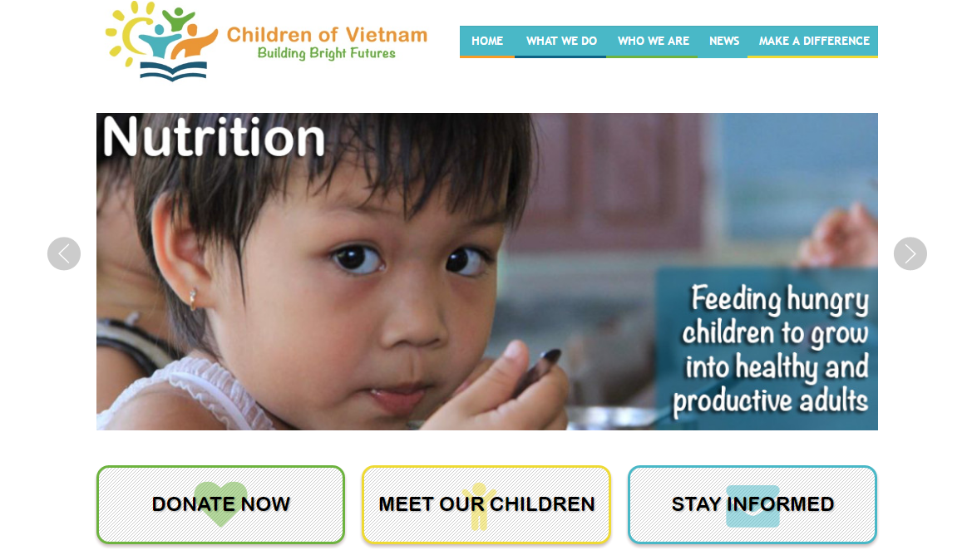

**Figure 1-1:** Website Childrenofvietnam

Childrenofvietnam is a website works solely as a volunteer, and does not receive a salary or compensation. They spend nothing on marketing, advertising, or solicitations.

* **Advantages:**
* Has friendly user interface
* **Disadvantages:**
* Only support PayPal. The language is English.
* No marketing or advertising so it is not popular in Vietnam.
* Only about children.
* **Lovingkindnessvietnam**

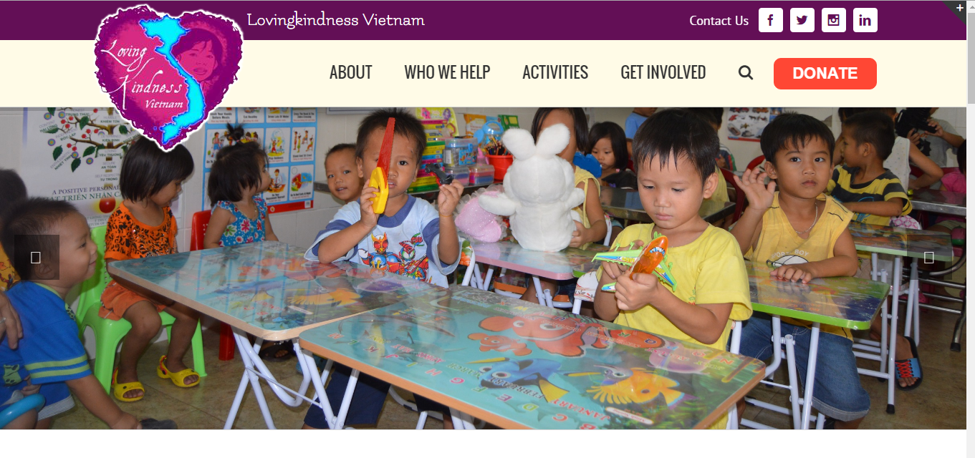

**Figure 1-2:** Website lovingkindnessvietnam

The mission of Lovingkindness Vietnam is to directly aid those in need throughout the area surround Nha Trang, Vietnam. Seeking out and visit the wonderful orphanages, charity schools, and communities, identify how best to improve the health and wellbeing of the children, and put into place programs to bring about lasting change. As they are a small charity dedicated to one area, they can oversee customized from donors overseas.

* **Advantages:**
  + Has friendly user interface
* **Disadvantages:**
  + Only support PayPal. The language is English.
  + No marketing or advertising so it is not popular in Vietnam.

# PROPOSAL

## The idea

Nowadays in our country, there are many people have difficult circumstances. Besides that, many organizations and personals have financial condition and possibilities for helping. But the problem is they can’t meet the other. Thanks for Internet, WS can solve this problem by making connections that enable people to help themselves and each other.

## Objectives

This event is the Capstone Event in FPT University studying program.

First, this event is responsibility for all team members. So we must complete all requirements from teacher and FU. During the time doing event, we can learn how to develop a event, how to manage event, how to working in group, how to control time, how to perform teamwork effectively. Moreover, we also have experience in .NET technology, website designing, software testing. Therefore, we think this event is very necessary for us to improve skills, knowledge which we studied in FU. This event also makes our CV more beautiful after graduating from FU. This is also an opportunity for us to prove capacity with recruiters.

Second, we hope that out event can help the other people and we hope to make our country better.

## Brief description about system

This software has friendly and attractive interface, users can easily find out the event to donate or create a new event when they have enough capacity and capability. User also can send opinion to admin if they need help.

WS uses familiar technologies as: Bootstraps, .NET MVC5, AngularJS…, and we are planning to develop a mobile version for easily connecting.

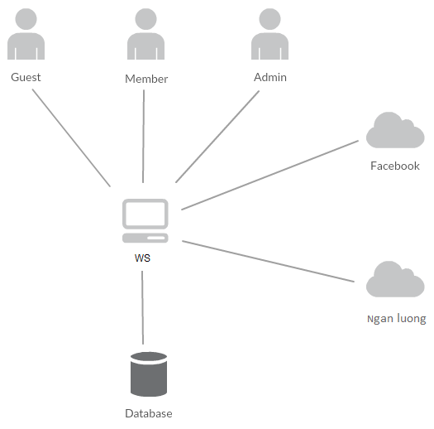

**Figure 1-3:** Brief descriptions diagram of WS system

## System features

About the features of WS, we focus to provide for users main features as searching, create new event, create thread, donate, message etc. Admin can manage members, manage organization, manage database, manage contribute database and manage Q&A.

In here, we focus on features which can help users can understand the best way what user want to have with features of WS. There are the detailed features of WS:

### Client features

* Register: User can register an account and login to use all features of WS.
* Login/Logout: Users login/logout an account to use or exit system WS.
* Event
  + Create new event: Organization can create new program with basic info, contact, timeline and content.
  + Update program Information: User can change and update information of program which has been created.
  + Chat room: An event has a room chat where all user whom connected in can chat with the others.
  + Comment/Remind: Users can comment/remind an program to follow and discuss with another users.
  + Report: User can report a event which violate regulation to administrator.
* Thread:
  + Create new thread: Users can create new thread for discuss with other or get ideal about creating an event
  + Comment/Remind: Users can comment/remind a thread to follow and discuss with another users.
  + Report: User can report a thread which violate regulation to administrator
* Donate: User can donate money to help event and get point rewards.
* Organization:
  + Create new organization: Users can request create new organization.
  + Create a new event to raise donate.
  + Update profile: Organization can change or update information.
  + Manage created event.
* Profile:
  + Change password: User can change password to keep security.
  + Update profile: User can change or update information.
  + Manage created event, donated event, created thread. View statistical event had created, backed.
  + Sent/Receive message: Users can send to or receive from other users to discuss about event.
* Search:
  + Users can search any what they want follow: account, thread, event, organization.
* Message:
  + Users can message with others: members or admin.
* Report:
  + Users can report others users, events, threads, organizations.

### Admin features

* Manage user:
  + Search user: Admin can search with name of user and system will display simple information about that user(name, email, phone number)
  + Inactive/active user: admin can set user’s account to inactive or active.
* Manage event:
  + Search event:
    - Search with event name: Admin can search with name of event and system will display simple information about that event.
  + Edit status: Admin can set status of an event: Inactive/active depend on report.
* Manage thread:
  + Search thread :
    - Search with thread name: Admin can search with name of thread and system will display simple information about that thread.
  + Edit status: Admin can set status of an thread: Inactive/active depend on report.
* Manage organization:
  + Admin manages creating organization requests from users. It means admin can accept or not a request.
  + Edit status: Admin can set status of an organization: Inactive/active depend on report.
* Manage report:
  + Admin recives reports of users. It means admin can accept or not a request.
* Message: Admin can view received messages/sent messages.
  + Compose new message: Admin can compose new message to send to user.

# BENEFIT FROM PRoject

## For our group

After developing and implementing this event, our group will get some benefits:

* Have more experiences of software event management how to manage plan, time, member and risk.
* Have more knowledge and skill about .NET MVC5 and AngularJS programming
* Know how to communicate with team members and how to teamwork more effective.

## For Community

Just need to have a device that connect to the internet and any web browser, user can:

* Easy join to a charity event to help other people who need.
* Easy to create a new charity event

# CRITICAL ASSUMPTION AND CONSTRAINTS

* Critical assumption:
  + Training: All developers can train .NET and AngularJS in 2 weeks. Before starting this event, just 2 members in our team have knowledge about .NET and only one member have knowledge about AngularJS, but with programming techniques which we studied at FU, we have to try the best to not missing any deadline in event plan.
  + Human resources: Assume that all members in team have a good healthy to do their tasks.
* Constraints:
  + Time and deadline: We must complete task on time. We work on 14 weeks, each member works 5 hours/day and 5 days/week. We do not have more time for us to complete developing and deliver application to teachers. Besides, we have to submit report documents before deadline to teacher can review.
  + Quality: The products must be run well when users perform main functions in Google Chrome 53
  + Process: We have to follow the software processing of FPT Software
  + Human resources: There are 5 members in our team, each member have to study 2 subjects (Japanese and JIT) at school.

# POTENTIAL RISKS

After studying about this event, we find out some problem that we may be encountered:

* Under-estimate scope and time or miss deadline because lack of experience in group working, managing and controlling work.
* Loss data, source code before uploading data to server because of careless.
* Equipment got broken because of careless or accident.
* Human resources: Team member cannot complete their works because of health reasons, key member leave team or un-cooperating on team.
* Change requirements: Requirement changed when some functions cannot be completed or some technologies is not suitable.

# REFERENCES

* **Lovingkindnessvietnam at URL:**  <https://www.Lovingkindnessvietnam.org/>
* **Childrenofvietnam at URL:** <https://www.Childrenofvietnam.com/>